Eduardo Gallego Chillón - 2º DAW

IES Francisco Ayala (Granada)

**LAMP platform installation guide**



**Index**

**1. Apache installation 2**

**2. PHP installation 2**

**3. MySQL Client installation 2**

**4. MySQL Server installation 3**

**5. MySQL Workbench installation 3**

**6. PhpMyAdmin installation 4**

**6.1. PhpMyAdmin server selection 4**

**6.2. PhpMyAdmin password introduction 4**

**6.3. PhpMyAdmin password confirmation 5**

**6.4. Apache working check 5**

**7. Stop, start, restart or reload Apache Server 6**

# Let’s start installing Apache, an open source HTTP web server, identified as root user with the following command:

**sudo apt install apache2**

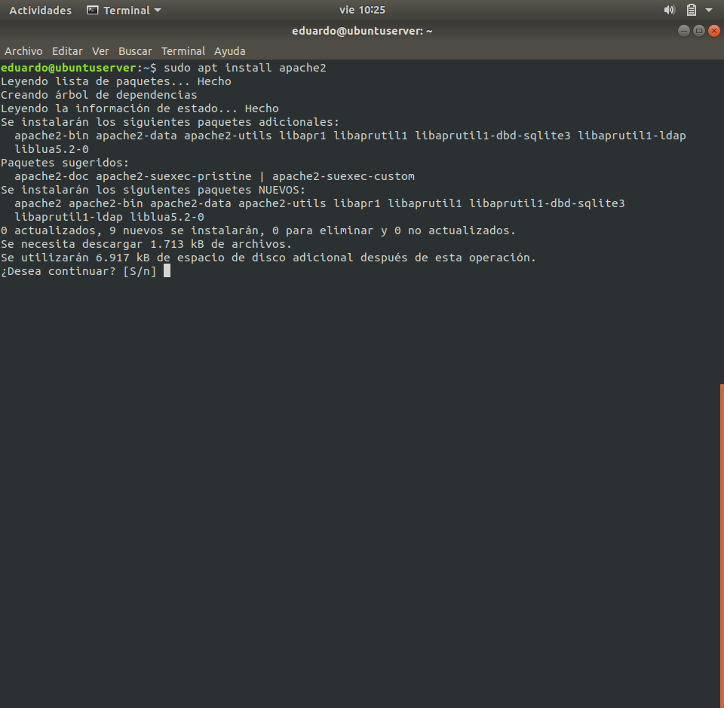

Fig. 1 - Apache installation

# Next, we install PHP, an open source language used in web development and that can be embedded in HTML. It can be installed with this command:

**sudo apt install php**

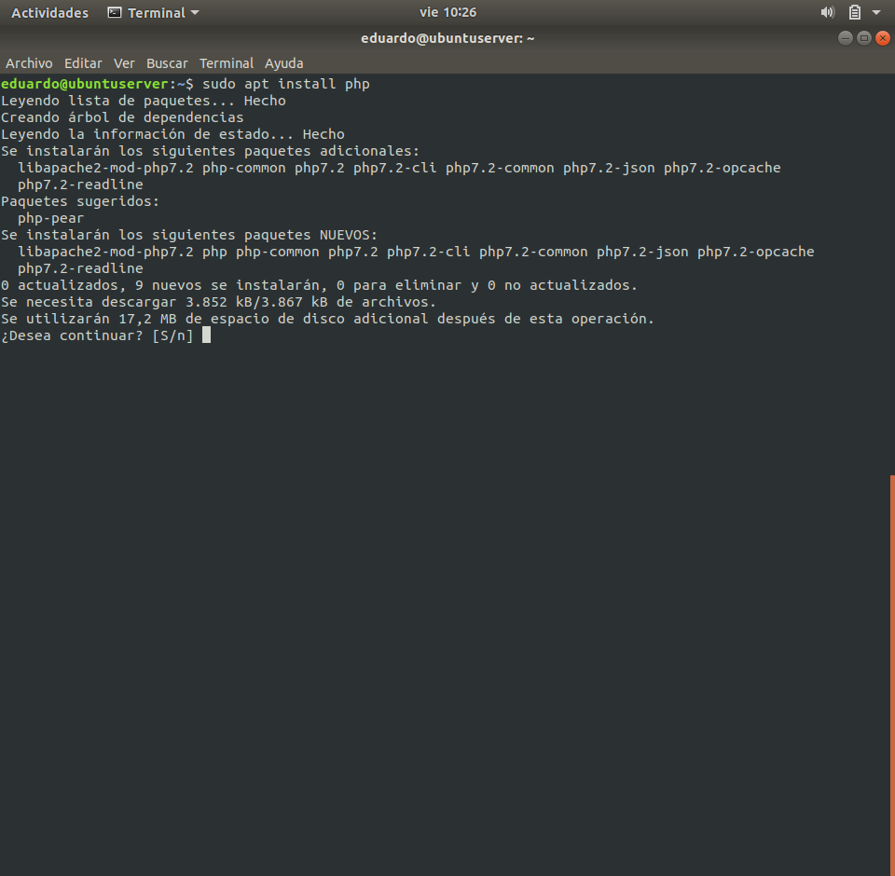

Fig. 2 - PHP installation

# Next step consists in install MySQL Client, a command-line client for MySQL database, executing:

**sudo apt install mysql-client**

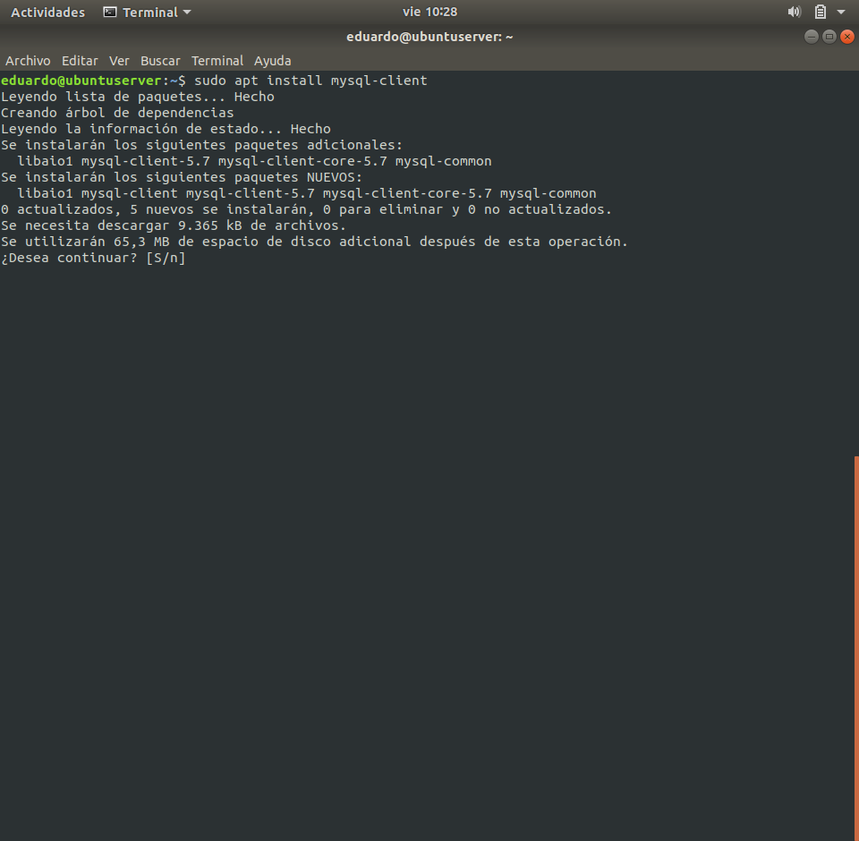

Fig. 3 - MySQL Client installation

# Also is necessary to install MySQL Server, a relational database management system, for the client works:

**sudo apt install mysql-server**

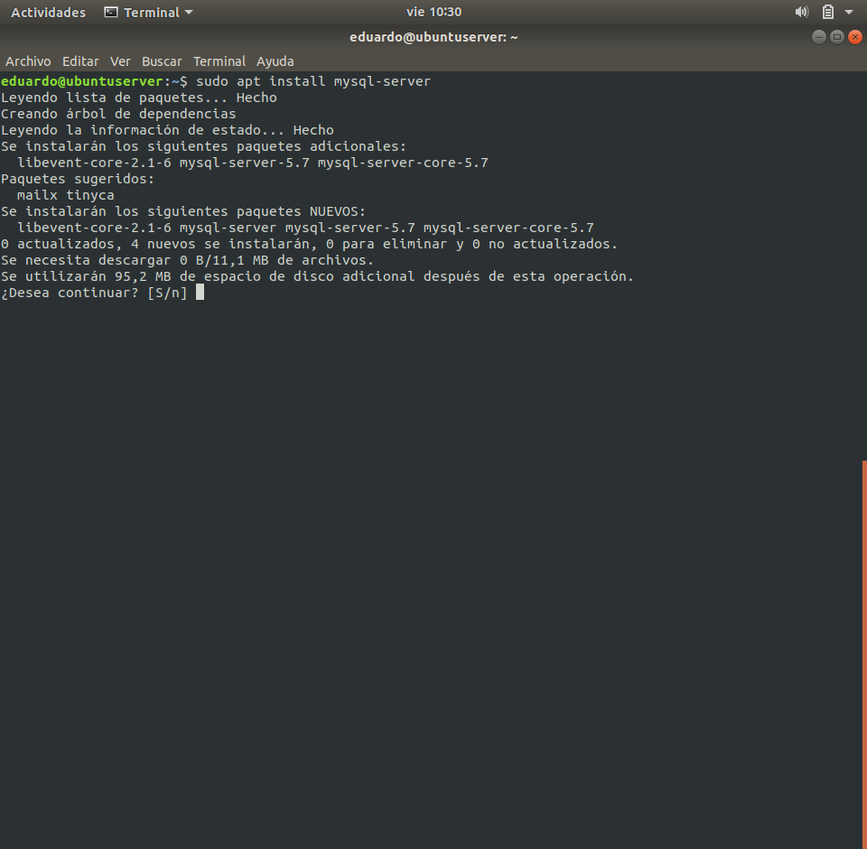

Fig. 4 - MySQL Server installation

# Optionally it can be installed MySQL Workbench (before called MySQL Query Browser, a GUI client for MySQL, using this command:

**sudo apt install mysql-workbench**

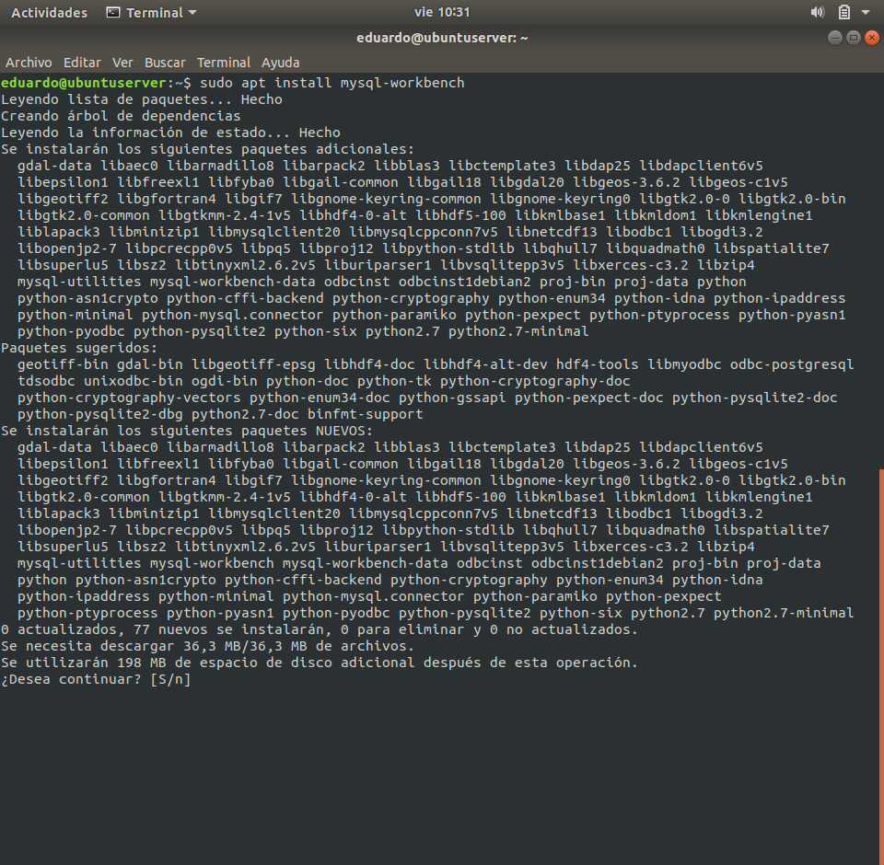

Fig. 5 - MySQL Workbench installation

# For finish the LAMPP platform installation, we install PhpMyAdmin, a MySQL administration tool coded in PHP:

**sudo apt install phpMyAdmin**

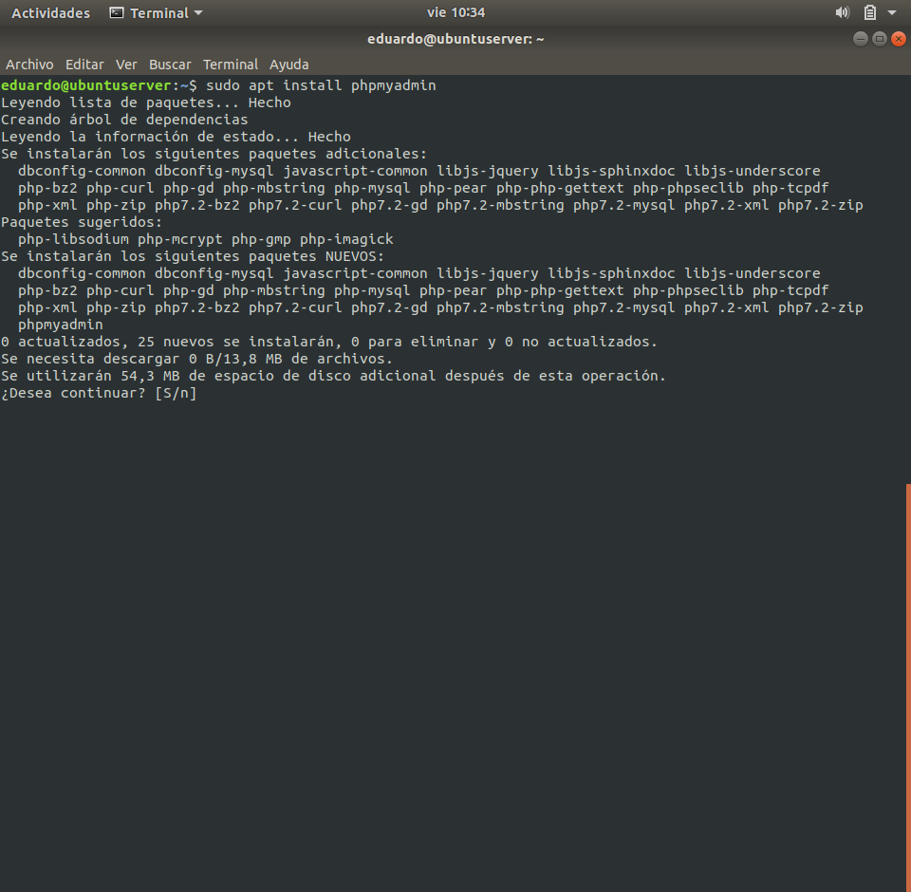

Fig. 6 - PhpMyAdmin installation

## In the installation, we are asked for choose the server used by PhpMyAdmin. We choose ***apache2*** as web server.

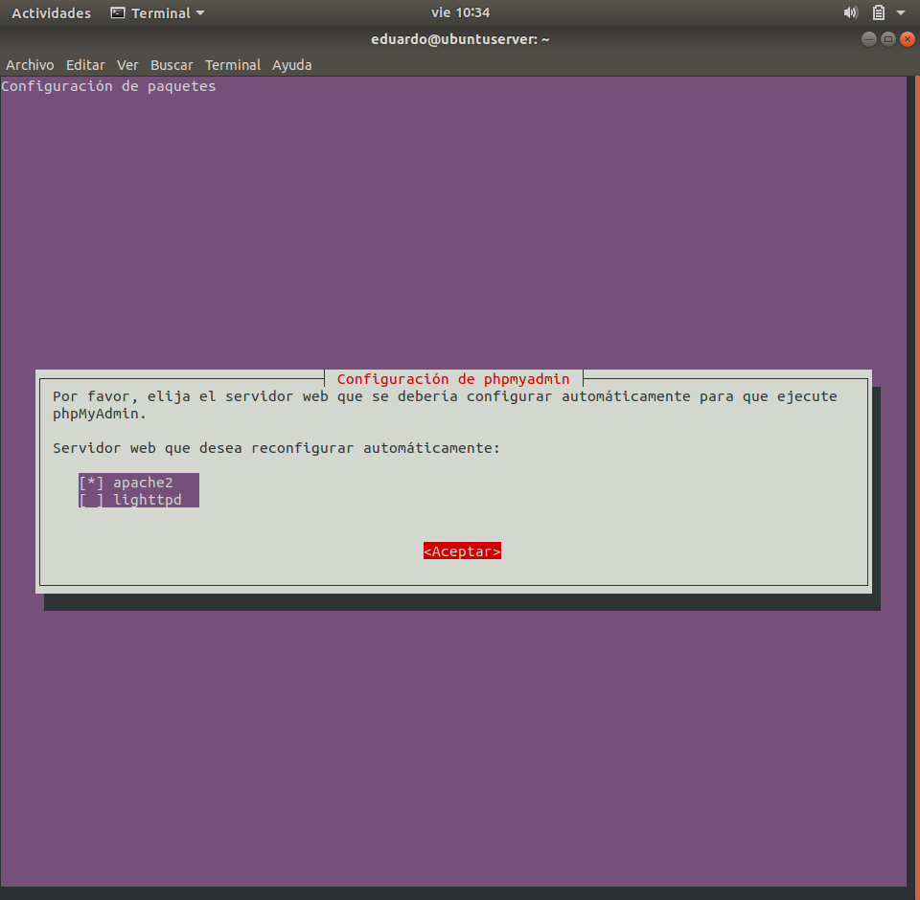

Fig. 7 - PhpMyAdmin server selection

## Next, we install and configure a database for use PhpMyAdmin, saying yes in this step:

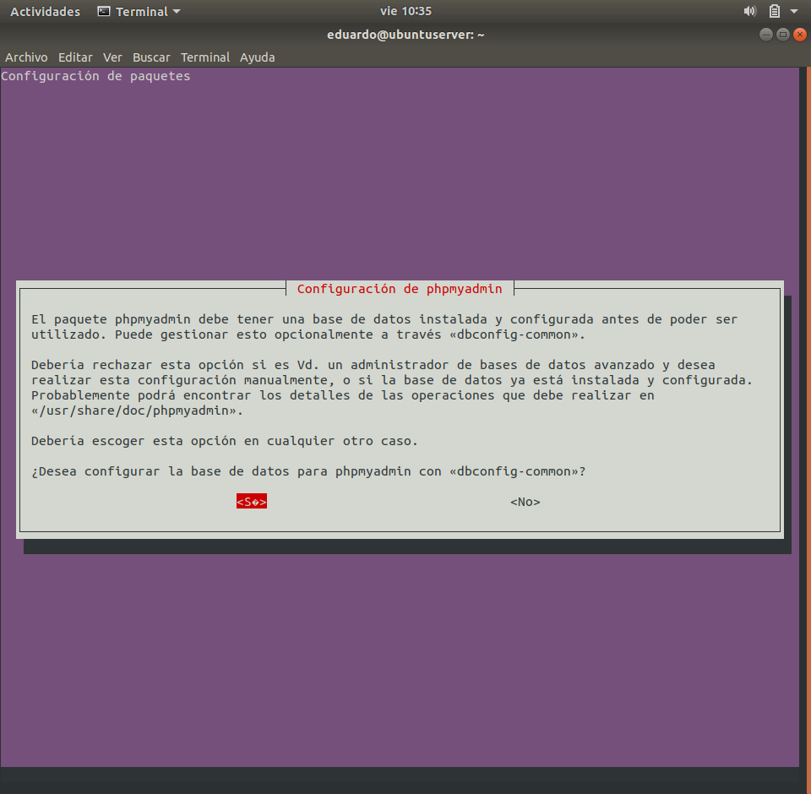

Fig. 8 - PhpMyAdmin database installation and configuration

## Then, we are asked for enter a password and his confirmation for what PhpMyAdmin can connect with MySQL server.

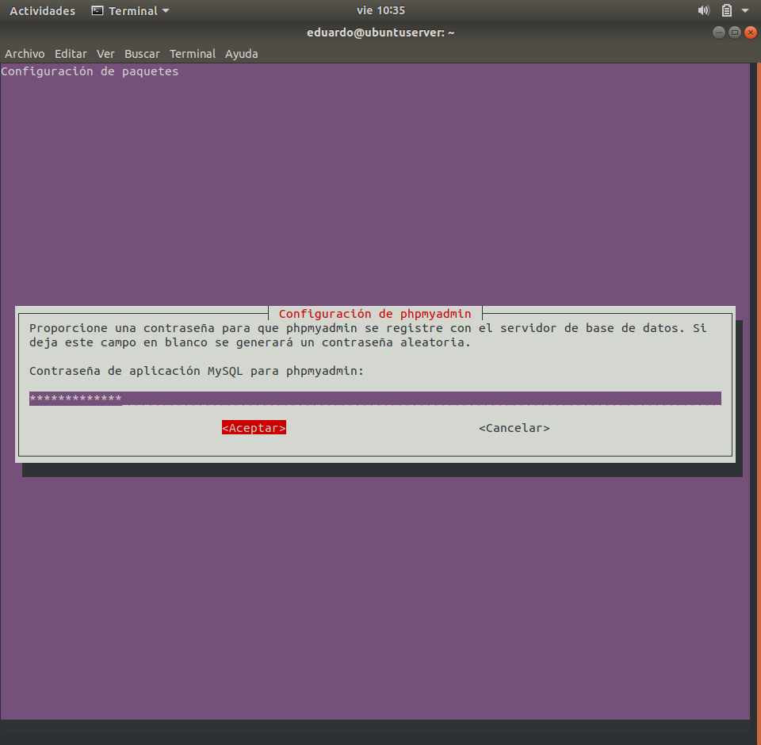

Fig. 9 - PhpMyAdmin password introduction

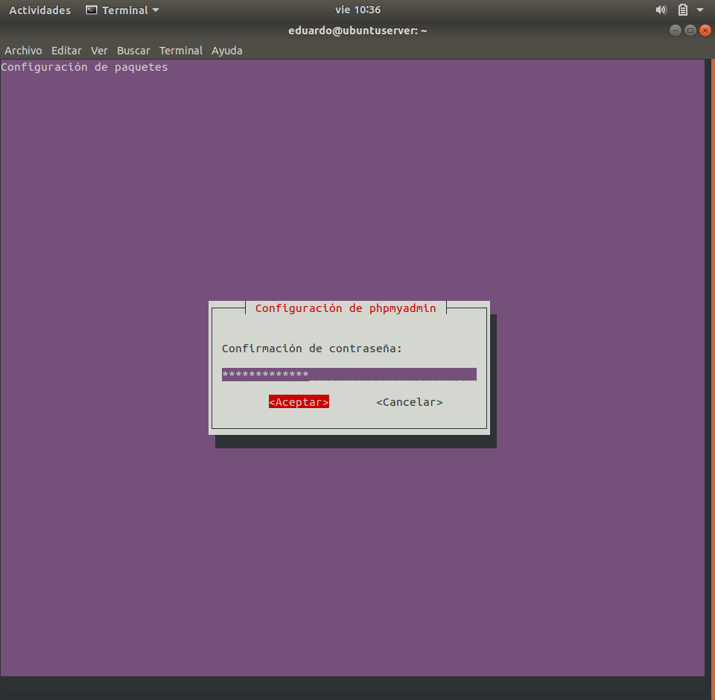

Fig. 10 - PhpMyAdmin password confirmation

## Once everything is installed, we check if it works from a browser writing this URL in the direction bar:

**http://localhost** or **http://127.0.0.1**

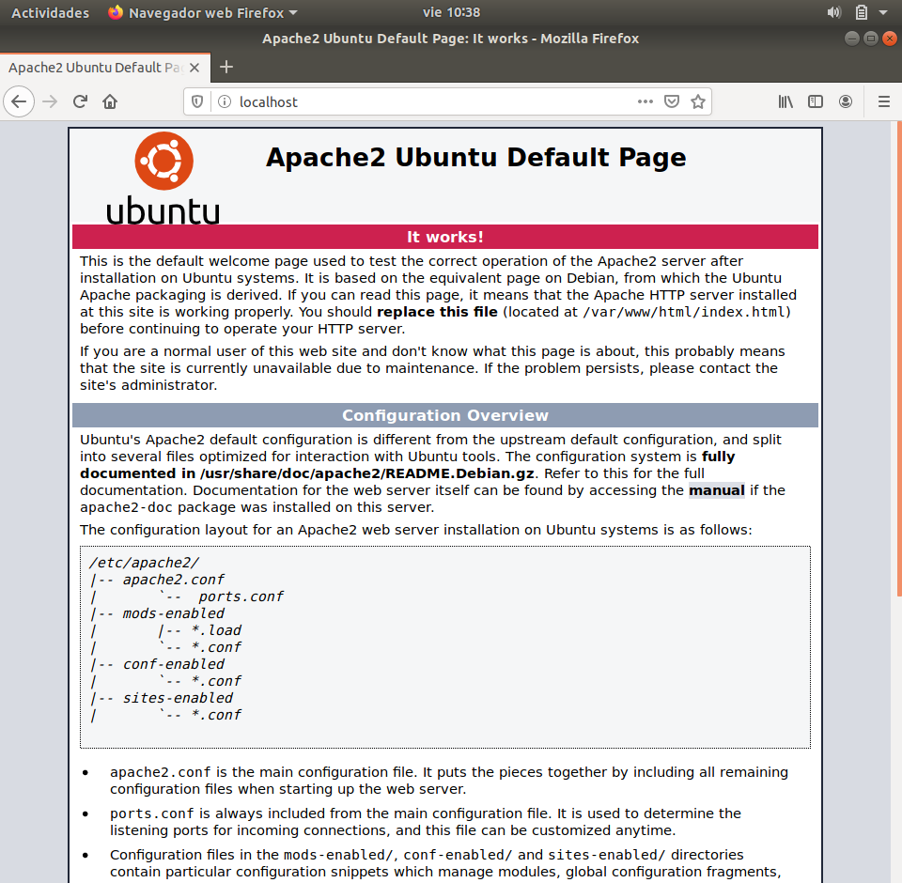

Fig. 11 - Apache working check

## If in any moment we want to stop, start, restart or reload Apache Server, we can use these commands:

**sudo /etc/init.d/apache2 stop** or **sudo service apache2 stop**

**sudo /etc/init.d/apache2 start** or **sudo service apache2 start**

**sudo /etc/init.d/apache2 restart** or **sudo service apache2 restart**

**sudo /etc/init.d/apache2 reload** or **sudo service apache2 reload**

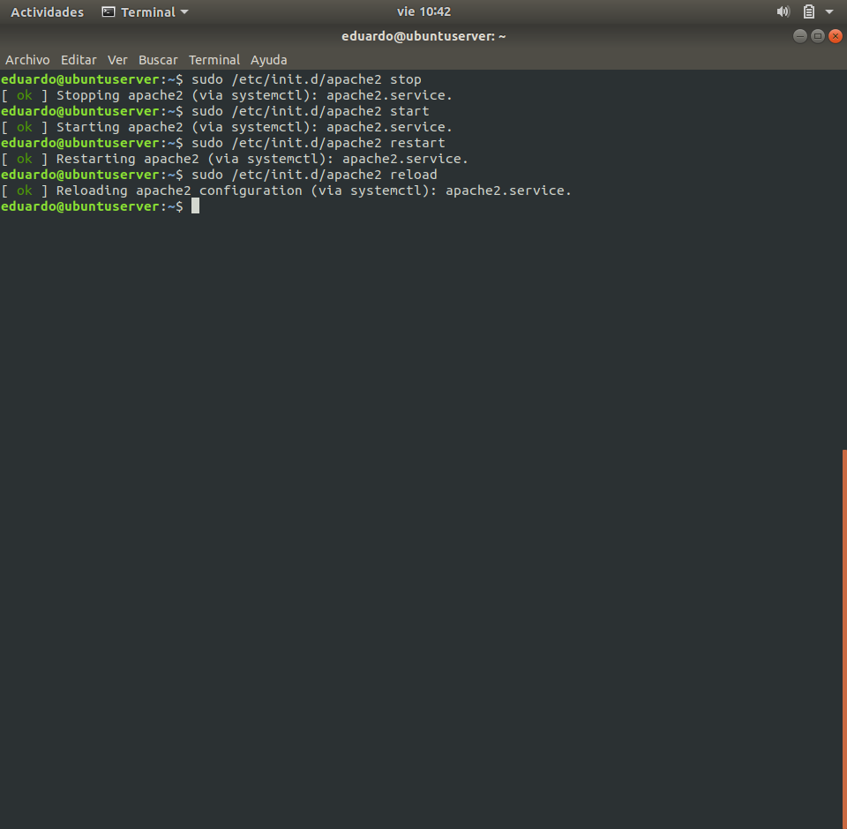

Fig. 12 - Apache Server stopping, starting, restarting and reloading